Project Design Phase-II

Data Flow Diagram & User Stories

Date | 4 Feb 2026
Team ID | LTVIP2026TMIDS60231
Project Name | ToyCraft Tales: Tableau's Vision into Toy Manufacturer Data
Maximum Marks | 4 Marks

Data Flow Diagrams:
Data Flow Diagram (DFD) is a methodology of graphical structural analysis and information systems design, which describes the sources external in respect to the system, recipients of data, logical functions, data flows and data stores that are accessed. DFDs allow to identify relationships between various system's components and are effectively used in business analysis and information systems analysis. They are useful for
system’s high-level details modeling, to show how the input data are transformed to output results via the sequence of functional transformations. For description of DFD diagrams are uses two notations — Yourdon and Gane-Sarson, which differ in syntax. Online Store DFD example illustrates the Data Flow Diagram for online store, the interactions between Customers, Visitors, Sellers, depicts User databases and the flows of Website Information. ConceptDraw DIAGRAM enhanced with Data Flow Diagrams solution lets you to draw clear and simple example of DFD for Online Store using special libraries of predesigned DFD symbols.

User Type | Functional  Requirement (Epic) | User Story Number | User Story / Task | Acceptance criteria | Priority | Release

Data Analyst | Data Access | USN-1 | As a data analyst, I can log into the Tableau dashboard using secure credentials.. | I can securely access dashboard data | High | Sprint-1

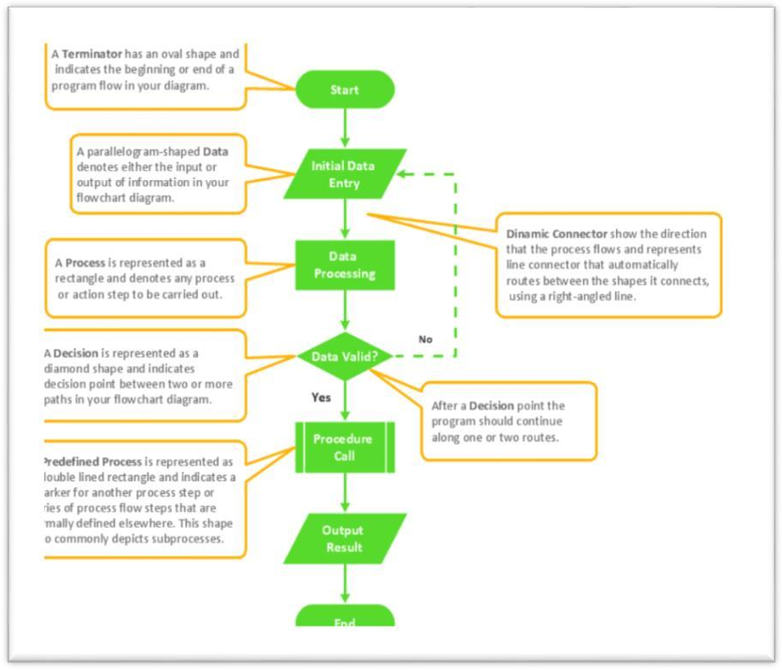
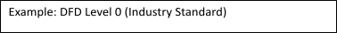
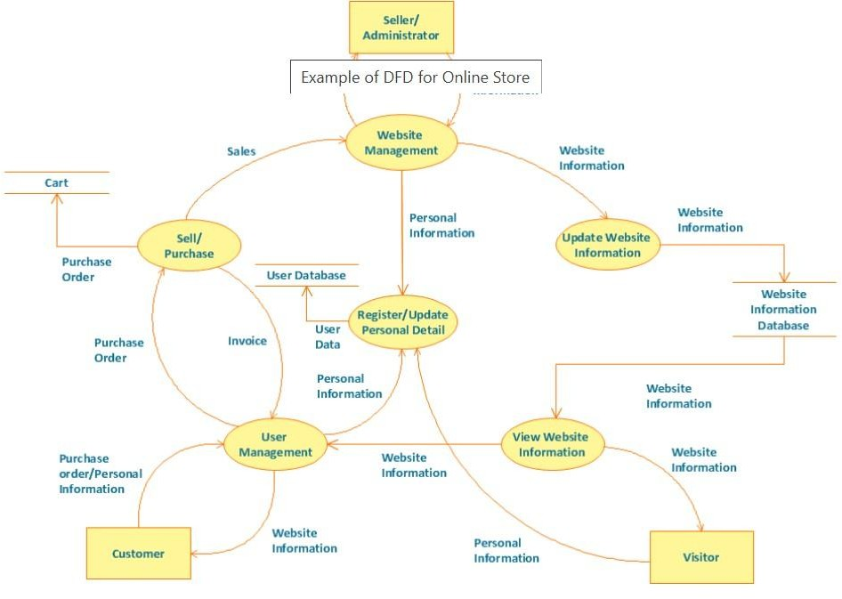
Example: (Simplified)

User Stories
Use the below template to list all the user stories for the product.

 | Dashboard Filtering | USN-2 | As a data analyst, I can filter sales data by product, region, or date. | Filters work correctly and update | High | Sprint-1
 | Exporting Data | USN-3 | As a data analyst, I can export dashboard data into CSV or Excel for further analysis | Data is exported accurately | Medium | Sprint-2
Business Manager | KPI Monitoring | USN-4 | As a manager, I can view key performance indicators (KPIs) such as revenue, product performance, and regional sales. | KPIs are clearly displayed and updated regularly | High | Sprint-1
 | Trend Analysis | USN-5 | As a manager, I can analyze sales trends over different time periods using line and bar charts. | Charts respond to input and show correct trends | Medium | Sprint-2
 | Alerts & Notifications | USN-6 | As a manager, I can receive alerts when sales drop below a threshold in a particular region. | Notifications are triggered based on predefined rules | Medium | Sprint-3
Executive (CLevel) | Strategic Overview | USN-7 | As an executive, I can access a high-level summary of company performance across branches. | Dashboard displays concise, clear summaries | High | Sprint-1
 | Regional Comparison | USN-8 | As an executive, I can compare performance across branches and cities. | I can view comparative charts and tables | Medium | Sprint-2

 | Export to Presentation | USN-9 | As an executive, I can export charts and graphs directly for board presentations. | Exported visuals maintain design and data accuracy | Low | Sprint-3
System  Administrator |  | USN-10 |  | Role changes reflect immediately and | High | Sprint-1
 | User Role Management |  | As an admin, I can manage user roles and permissions for dashboard access. | restrict/allow access as expected
 | Data Source Integration | USN-11 | As an admin, I can integrate new data sources (Excel, SQL, etc.) into Tableau. | New data is correctly reflected in dashboards | High | Sprint-2
 | System Monitoring | USN-12 | As an admin, I can monitor system performance and usage statistics of the  Tableau server. | I can view uptime, load time, and user activity logs | Medium | Sprint-3

